**Roll Control:**

Visual Representation of the entire control algorithm:

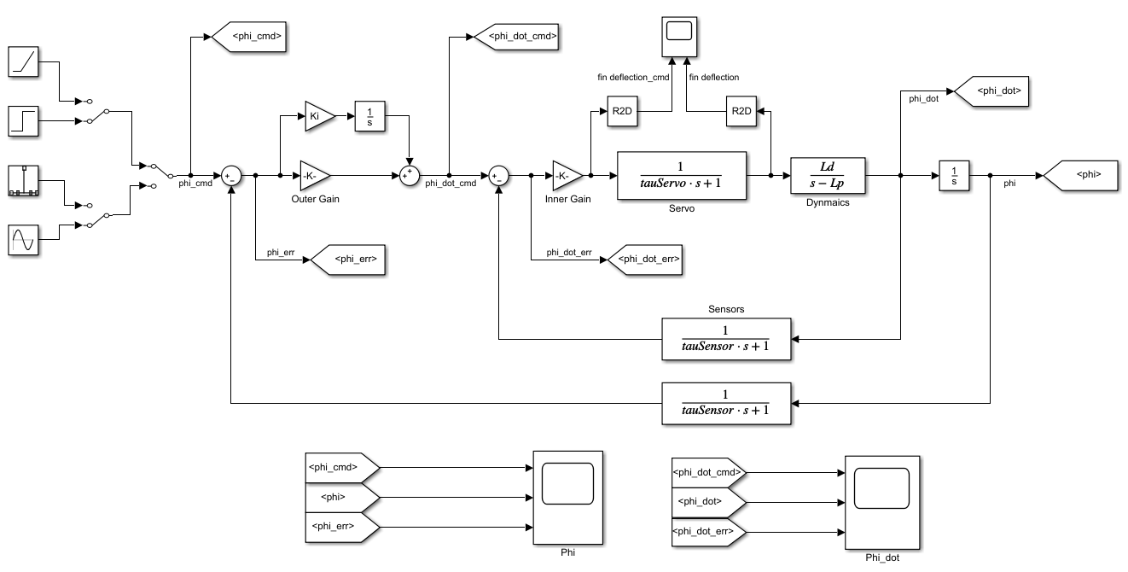

Time constants:

$$τ_{sensor}=0.01 s$$

$$τ_{servo}=0.1 s$$

Flight conditions:

$$U_{0}=228.4\frac{m}{s}≅0.67 Ma$$

$$α=β=0$$

$$ρ=1.225\frac{kg}{m^{3}}$$

Other Parameters

$$d=0.08 m$$

$$S=\frac{πd^{2}}{2}=0.005 \frac{m}{s}$$

$$I_{x}=6.331*{10}^{-3} kg m^{2}$$

$$C_{L_{p}}=-51$$

$$C_{L_{δ}}=4.03$$

**Inner loop design:**

Root locus:  
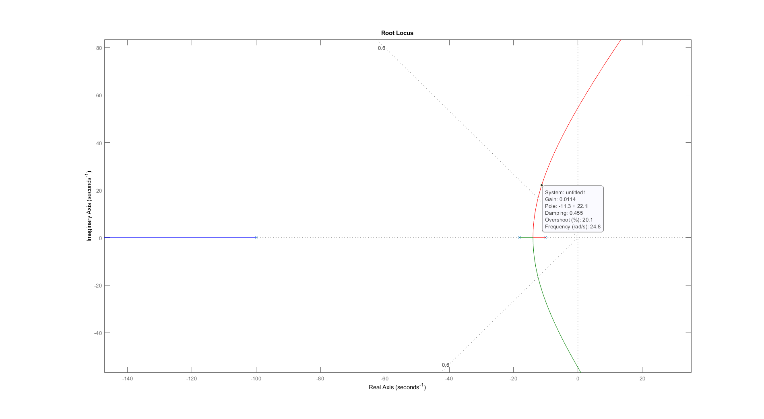

Choose an inner loop gain: $K_{p}=0.1$

**Outer Loop Design:**

Root locus

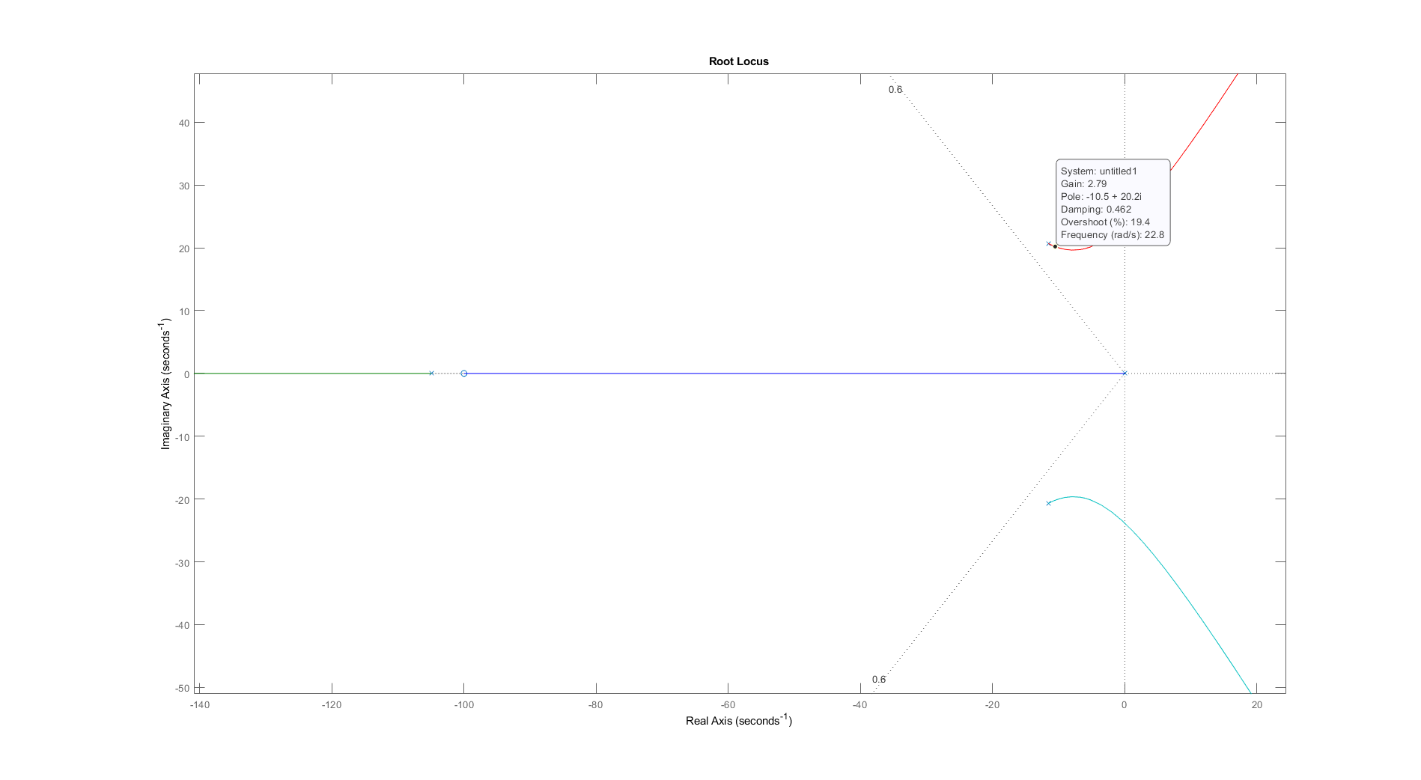  
Choose an outer loop gain: $K_{p}=3,$  
Add integral control for improved tracking of ramp input: $K_{i}=0.5$

**Gain and Phase Plots of Outer Loop:**

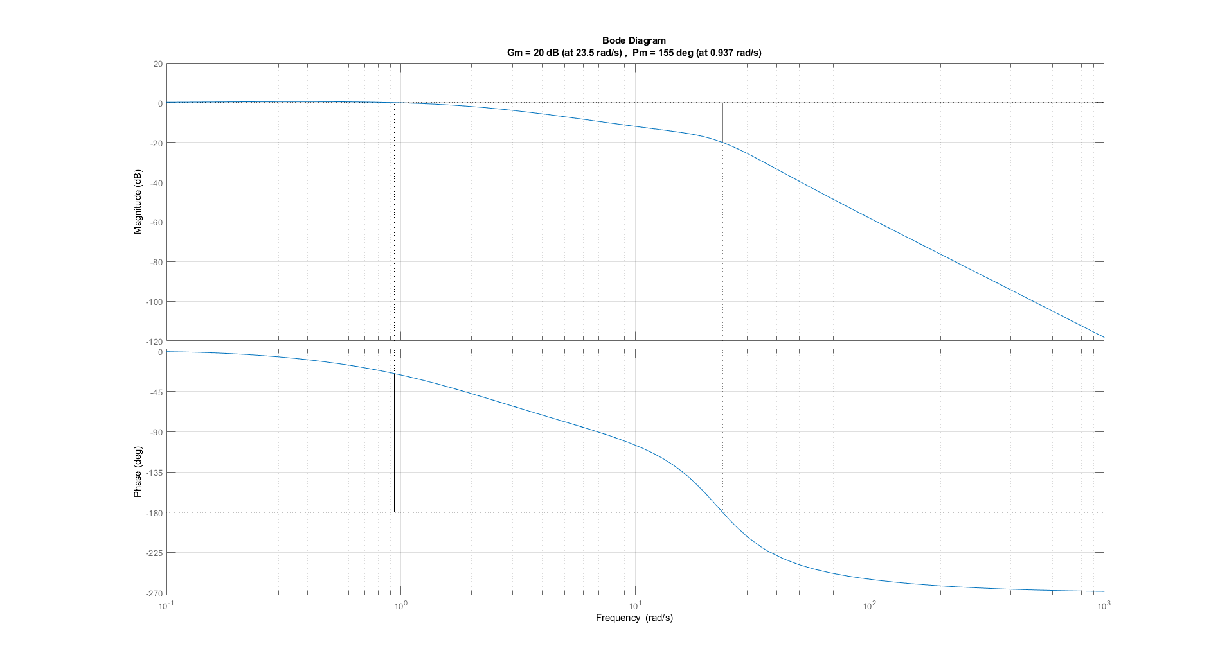

Gain margin: 20dB

Phase margin: 155deg

Bandwidth (-3dB): 2.53 rad/s

**Simulation:**

**Test 1:** Step input of 45 deg

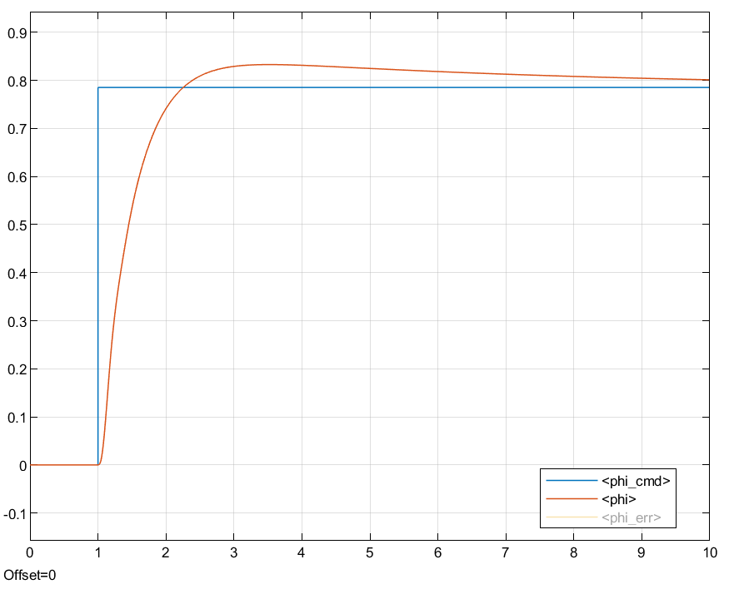 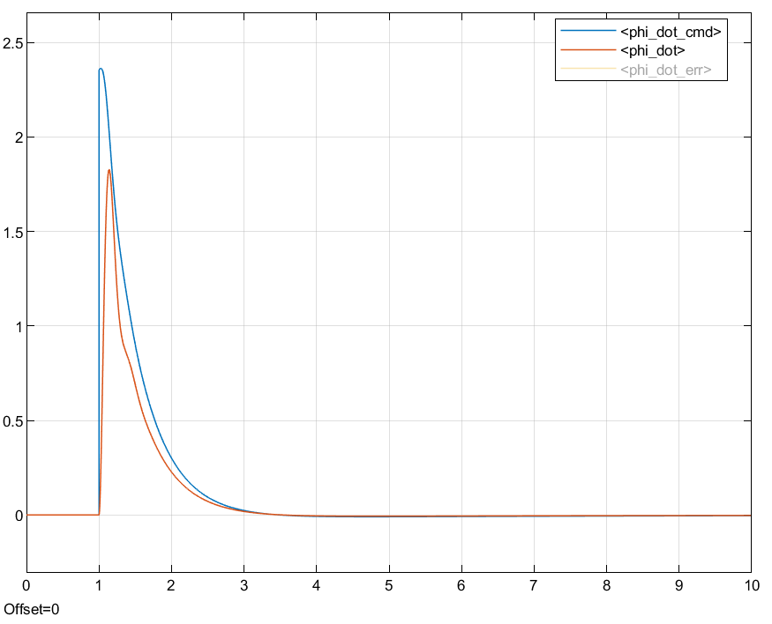

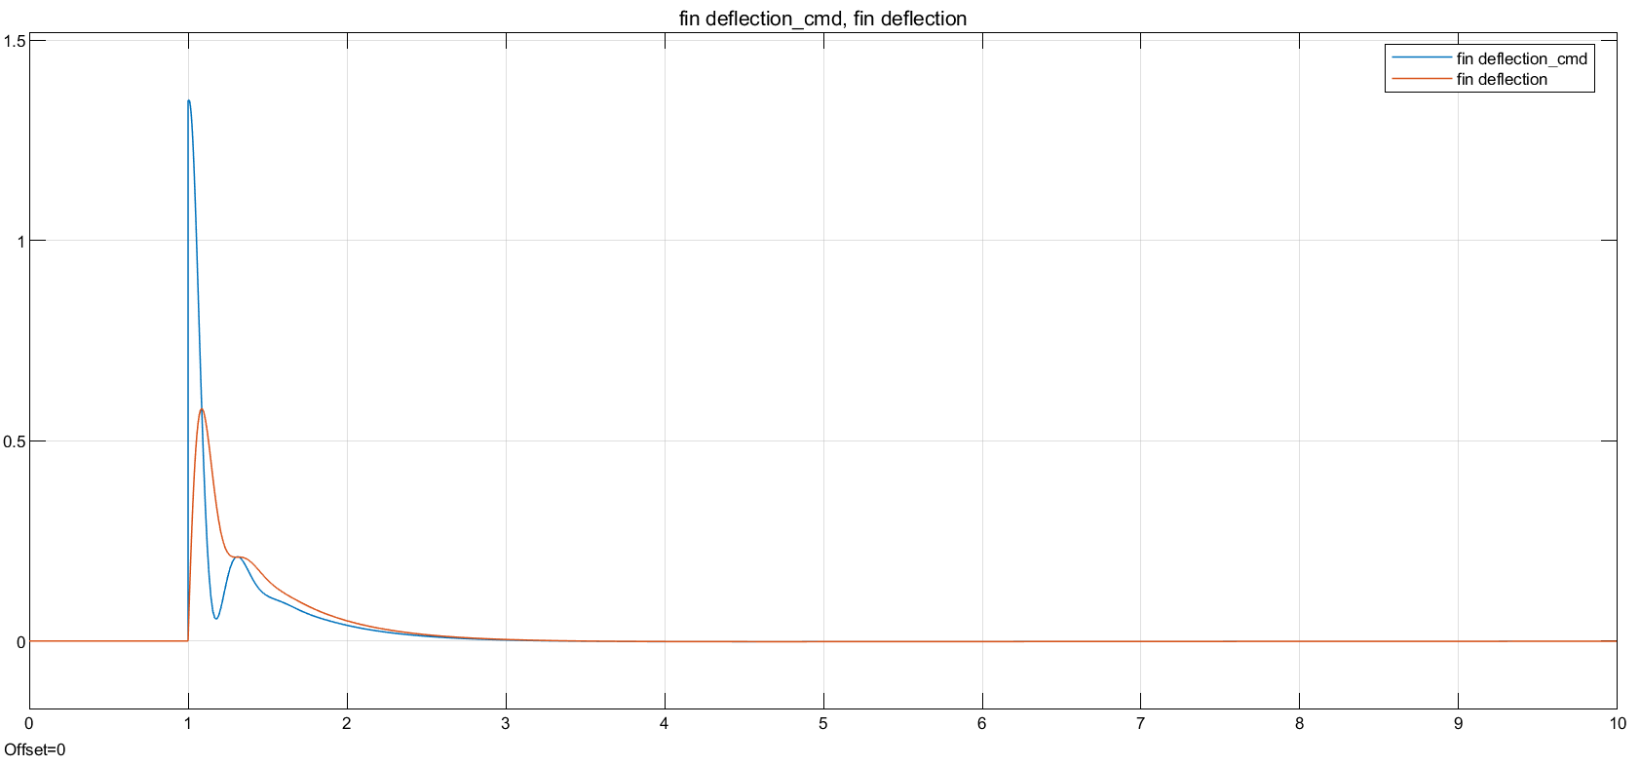

**Test 2:** Ramp input of 45 deg/s

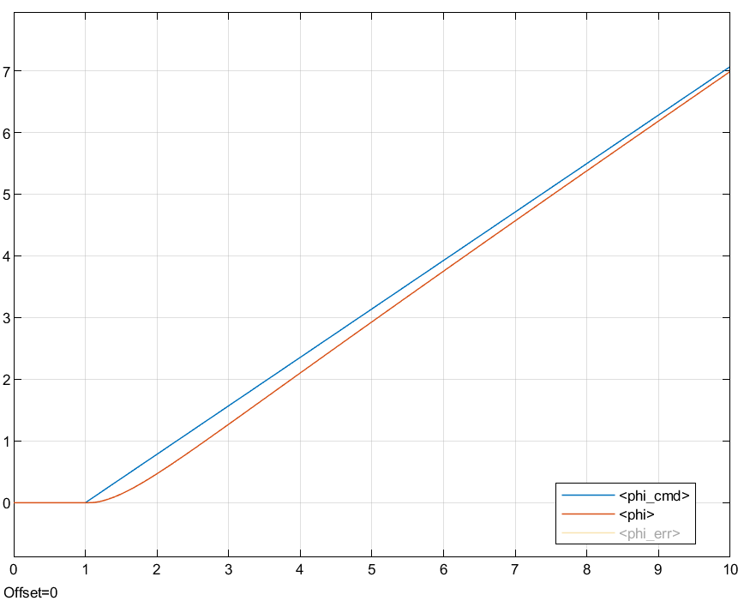 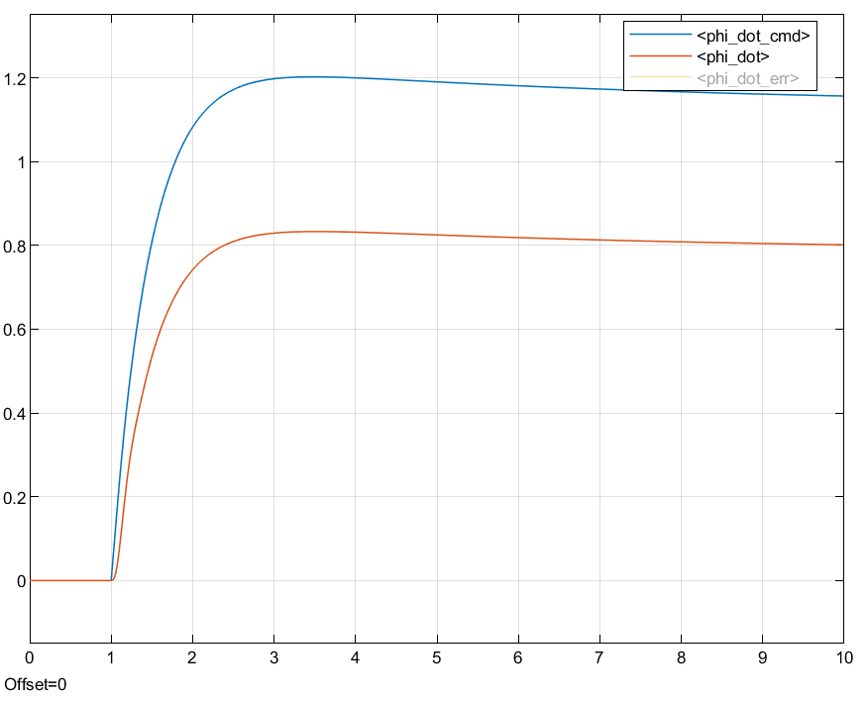 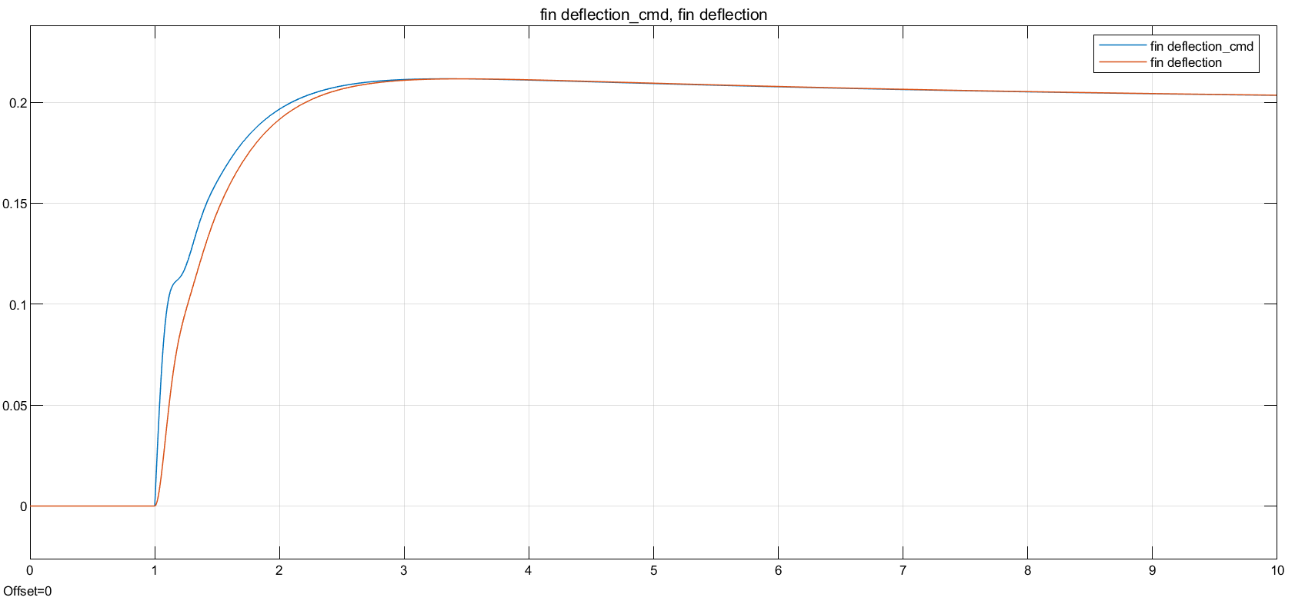

**Test 3:** Sine input (amplitude: 45 deg, Frequency: Pi rad/s)

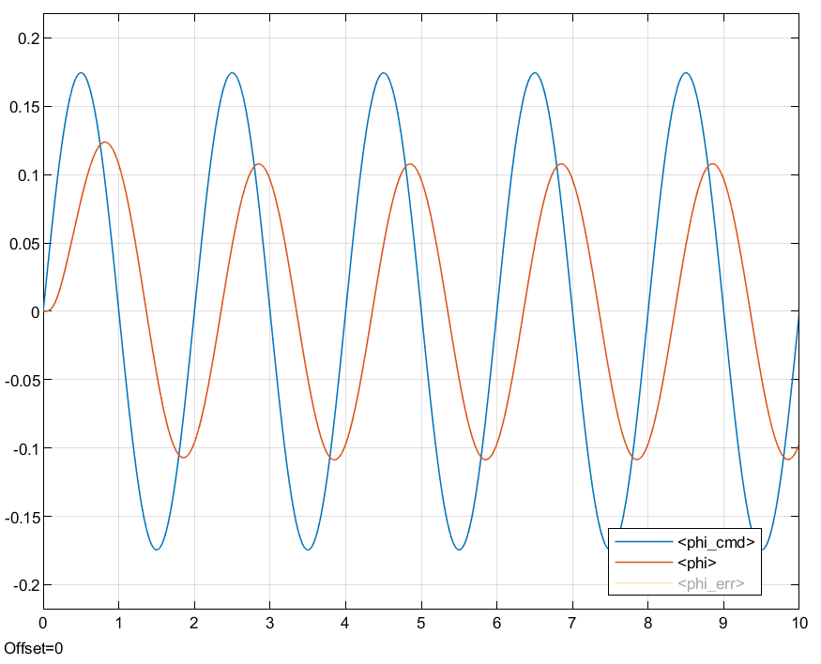 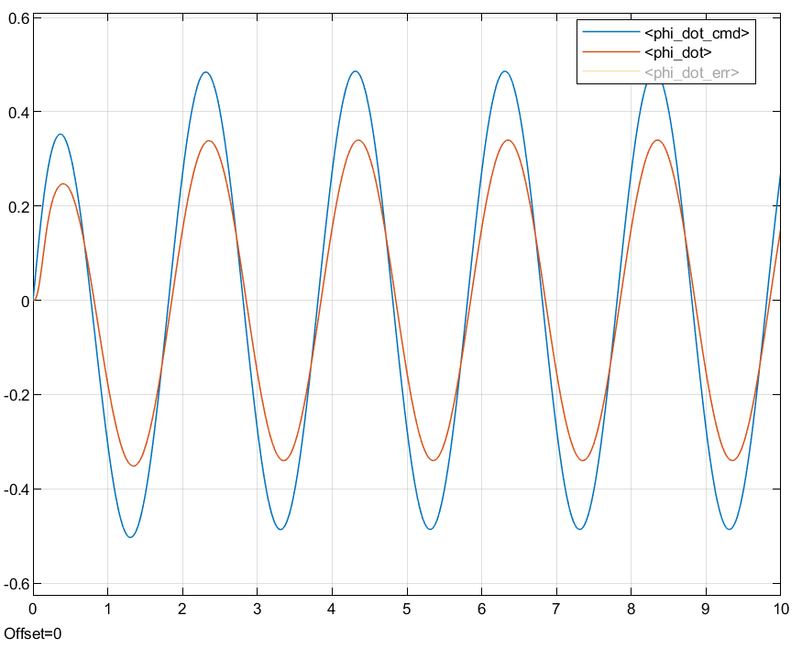 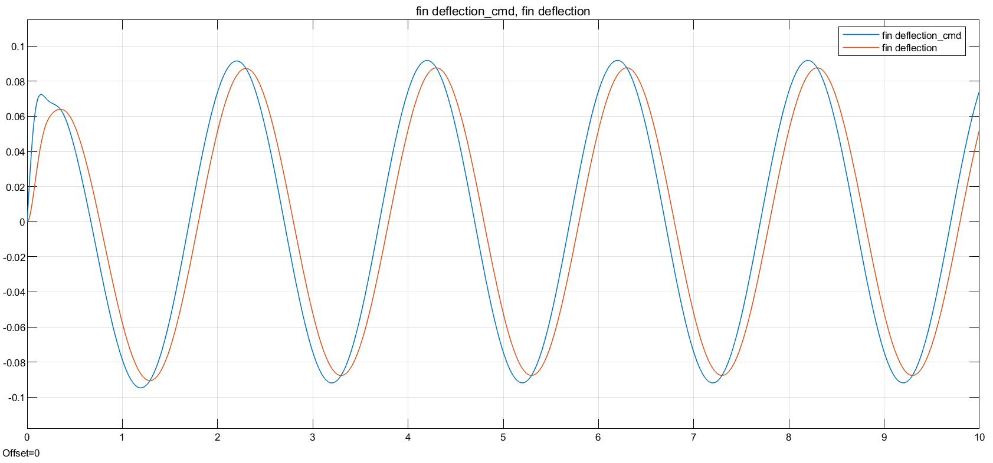

Matlab Code:

clear,clc

%% Parameteres

d = 0.08;

S = pi*d^2/4;

U0 = 228.4; % ~~ 0.67Ma

Ix = 6.331e-3;

rho = 1.225;

TechnionConfig = 1;

if (TechnionConfig)

Clp = -51;

Cld = 4.03;

else

load('aero.mat','Clp','Cl_delta_l');

Clp = Clp(6,9,9);

Cld = -Cl_delta_l(6,9,9);

end

Lp =rho*S*U0*d^2*Clp/(4*Ix);

Ld =rho*S*U0^2*d*Cld/(4*Ix);

tauServo = 0.1;

tauSensor = 0.01;

%% Inner Loop Design

dyn = tf(Ld,[1 -Lp]);

servo = tf(1,[tauServo 1]);

sensor = tf(1,[tauSensor 1]);

rlocus(dyn*servo*sensor)

sgrid(0.6,1e10)

Kinner=0.01;

%% Outer Loop Design

innerLoop = feedback((Kinner*dyn*servo),sensor);

int = tf(1,[1 0]);

rlocus(innerLoop*int)

sgrid(0.6,1e10)

Kouter = 3;

Ki = 0.5;

s = tf('s');

outerLoop = feedback((Kouter+Ki/s)*innerLoop*int,sensor);

%% Stability margins

margin(outerLoop)

systemBandwidth = bandwidth(outerLoop)

grid

sim('roll_control_loop');